INDUSTRIAL EXPOSURE TRAINING REPORT
@

Sri Krishna Engineering (SKE)

AI Powered E-Commerce Website
IET report submitted in partial fulfillment for the requirement of the Degree of

BACHELOR OF SCIENCE IN ARTIFICIAL INTELLIGENCE AND MACHINE LEARNING
BY
KOWSIC S
24BAI143

Under the Guidance of Under the Co-ordinator
Prof. A.V Anuja.,M.Sc.,M.Phil., Mr. Joseph Glyzen
Assistant Professor Python Developer
Altitudes Technologies

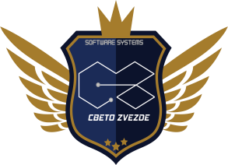
DEPARTMENT OF SOFTWARE SYSTEMS AND AIML
SRI KRISHNA ARTS AND SCIENCE COLLEGE COIMBATORE - 641008
JUNE 2026

DECLARATION

I hereby declare that the Industrial Exposure Training (IET) Report entitled “ AI Powered E-Commerce Website ” submitted in partial fulfillment of the requirements for the award of the degree of Bachelor of Science in Artificial Intelligence and Machine Learning is an original work carried out by me during the Industrial Exposure Training at Sri Krishna Engineering (SKE).

Place: Coimbatore Date:

Signature of the Candidate

CERTIFICATE

This is to certify that the IET report entitled “AI Powered E-Commerce Website” in partial fulfillment of requirements for the degree of Bachelor of Artificial Intelligence and Machine Learning is a record of bonafide work carried out by Kowsic S , 24BAI143 and that no part of this has been submitted for the award of any other degree or diploma and the work has not been published in popular journal or magazine.

GUIDE HOD DEAN

This Industrial Exposure Training Report is submitted for the Viva Voce Examination conducted on at Sri Krishna Arts and Science
College.

Internal Examiner External Examiner

ACKNOWLEDGEMENT

The satisfaction and euphoria of the successful completion of any task would be incomplete without the mention of the people who made it possible, whose constant guidance, encouragement, crowned my effort with success.
I have been fortunate enough to secure co-operation, guidance and assistance from a number of people. I am at a loss of how to express the deep sense of gratitude I have towards all of them.
I am greatly indebted to our Principal Dr. R. JAGAJEEVAN, MBA., Ph.D., Dean of Computer Science and Mathematics, Dr. K. S. JEEN MARSELINE, MCA, M.Phil., Ph.D., and Dr. S. DHANALAKSHMI, MCA., M.Phil., Ph.D., NET., Associate Professor and Head, Department of Software Systems and AIML, who has permitted for the fulfilment of the venture.
I would like to extend my thanks and unbound sense for the timely help and assistance given by Prof. A.V. Anuja.,M.Sc.,M.Phil., Assistant Professor, Department of Software Systems and AIML, Sri Krishna Arts and Science College in completing the training with their remarkable guidance at every stage of my IET was coupled with suggestions and motivation.
I owe my gratitude and thanks to Mr. Joseph Glyzen, Python Developer, Altitudes Technologies for permitting me to carry out the training.
I would like to express my sincere thanks to the God Almighty for his constant love and grace that he has bestowed upon me.
Finally, I thank my parents, family members, and my beloved friends for their moral support and encouragement without which I would not have been able to follow my dreams.

Kowsic S

ABSTRACT

AI Powered E-Commerce Website represents a modern and intelligent web-based platform developed to streamline online shopping and business management within a single integrated system. Built using the MERN Stack (MongoDB, Express.js, React.js, and Node.js), the application combines a responsive e-commerce storefront with a comprehensive administrative dashboard, enabling efficient product management, secure customer interactions, and data-driven business operations. Unlike conventional e-commerce platforms that primarily focus on online transactions, this system integrates Artificial Intelligence to provide business insights, customer assistance through an AI-powered chatbot, multilingual support, and advanced analytics for informed decision-making. Customers can securely browse products, manage shopping carts and wishlists, place orders through Razorpay payment integration, and monitor their order history, while administrators can efficiently manage products, users, inventory, orders, and sales performance through an interactive dashboard. The application incorporates secure authentication using JSON Web Tokens (JWT), encrypted password storage with Bcrypt, image upload functionality using Multer, email notifications through Node mailer, and AI-powered recommendations and insights using the Groq SDK. The frontend is developed with React, Vite, Tailwind CSS, and Framer Motion to provide a responsive and visually engaging user experience, while MongoDB ensures reliable and scalable data management. This documentation presents a comprehensive overview of the complete Software Development Life Cycle (SDLC), including requirement analysis, system architecture, database design, module implementation, testing methodologies, deployment strategies, and future enhancement opportunities. The project successfully demonstrates how modern full-stack development combined with Artificial Intelligence can deliver a secure, scalable, user-friendly, and intelligent e-commerce management solution that enhances customer satisfaction, simplifies business operations, and supports future digital transformation.

TABLE OF CONTENTS

CHAPTER NO | CONTENTS | PAGE NO
1 | INTRODUCTION | 1
2 | COMPANY PROFILE | 2
2.1 | QUALITY POLICY | 3
2.2 | HIGHLIGHTS OF THE COMPANY | 4
3 | SYSTEM SPECIFICATION | 6
3.1 | HARDWARE SPECIFICATION | 6
3.2 | SOFTWARE SPECIFICATION | 6
4 | DEPARTMENTS IN THE COMPANY | 7
5 | DETAILED DESCRIPTION OF SPECIALIZED DEPARTMENT | 10
6 | MODULE DESCRIPTION | 11
7 | CONCLUSION | 19
8 | FUTURE ENHANCEMENT | 20
9 | BIBLIOGRAPHY | 21
10 | APPENDIX | 22
A | SAMPLE SCREENSHOTS | 22
B | SOURCE CODE | 26
C | TIMESHEET | 33

INTRODUCTION

In today's rapidly evolving digital landscape, businesses increasingly rely on modern web technologies and intelligent software solutions to improve operational efficiency, enhance customer engagement, and maintain a competitive advantage. As part of the Industrial Exposure Training conducted at Sri Krishna Engineering, this project was undertaken to gain practical experience in full-stack web application development while understanding real-world software engineering practices. The project, AI-Powered E-Commerce Website, demonstrates the integration of modern web technologies, secure backend services, database management, and Artificial Intelligence to build a scalable and user-friendly business solution.

The primary objective of this training was to develop practical skills in full-stack software development using the MERN Stack, along with exposure to industry-standard technologies such as React.js, Node.js, Express.js, MongoDB, RESTful APIs, cloud-based services, secure authentication, payment gateway integration, UI/UX design, software testing, and project management. Altitudes Technologies provided valuable opportunities to understand professional software development workflows, coding standards, deployment practices, version control, and collaborative development methodologies. During the training, various concepts including responsive web application development, database design, API integration, AI-powered business insights, multilingual support, and secure transaction processing were explored and implemented.

The Industrial Exposure Training significantly enhanced practical knowledge of software development methodologies and industry best practices while strengthening problem-solving, analytical thinking, and technical implementation skills. It provided valuable exposure to the complete Software Development Life Cycle (SDLC), from requirement analysis and system design to development, testing, deployment, and maintenance. The experience successfully bridged the gap between academic learning and industrial application, enabling the development of a comprehensive AI-powered e-commerce and management platform capable of addressing real-world business requirements through modern technologies and intelligent automation.

COMPANY PROFILE

Sri Krishna Engineering is a leading IT consulting, software development, and technology training company headquartered in Coimbatore, Tamil Nadu. Established by experienced software professionals, the organization specializes in delivering innovative, scalable, and customer-centric digital solutions that help businesses improve operational efficiency, optimize workflows, and accelerate digital transformation. The company offers a comprehensive portfolio of services, including custom software development, web and mobile application development, enterprise resource planning (ERP) solutions, cloud-based applications, API integration, IT consulting, software training, and HR consultancy. With a strong commitment to quality, innovation, and customer satisfaction, Altitudes Technologies develops reliable and cost-effective solutions tailored to meet the unique business requirements of clients across various industries.
The company leverages modern technologies to build secure, scalable, and high-performance applications. In addition to software development, Altitudes Technologies provides specialized services in UI/UX design, digital marketing, quality assurance, project management, and customer support, ensuring complete end-to-end technology solutions. Through its highly skilled professionals, adherence to industry best practices, and focus on continuous innovation, Altitudes Technologies continues to empower organizations with intelligent digital solutions that enhance productivity, improve business performance, and support sustainable growth in today's rapidly evolving technological landscape.
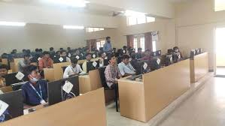

QUALITY POLICY

At Sri Krishna Engineering, our commitment is to deliver high-quality engineering products and digital solutions that consistently meet or exceed customer expectations. We strive to provide reliable, innovative, and cost-effective solutions by combining modern technology with industry best practices while maintaining the highest standards of quality, safety, and customer satisfaction.

We achieve this by understanding the specific requirements of our customers and implementing efficient engineering processes, modern software development methodologies, and continuous quality assurance practices. Our team is committed to innovation, technical excellence, teamwork, and continuous learning to ensure that every product and service delivered is secure, scalable, and aligned with industry standards. We continuously evaluate and improve our processes, technologies, and workflows to enhance operational efficiency and product reliability.

At Sri Krishna Engineering, customer satisfaction remains our highest priority. We believe in building long-term relationships through trust, transparency, and consistent quality. By maintaining a culture of continuous improvement, responsible engineering practices, and technological innovation, we aim to deliver solutions that create lasting value, improve business performance, and contribute to sustainable growth for our customers and stakeholders.

HIGHLIGHTS OF THE COMPANY

Sri Krishna Engineering is a growing engineering and industrial solutions company committed to delivering high-quality products and innovative services. The company combines engineering excellence with modern digital technologies to improve productivity, operational efficiency, and customer satisfaction

Comprehensive Engineering Solutions
Provides a wide range of engineering products and services, including industrial equipment, mechanical components, customized engineering solutions, product consultation, maintenance support, and after-sales services to meet diverse customer requirements.

Modern Technologies Integration
Utilizes advanced technologies such as Artificial Intelligence, cloud computing, database management systems, automation tools, and modern web technologies to streamline business operations, improve decision-making, and enhance customer experience through digital transformation

Customer-Centric Digital Platform
Offers an intelligent and user-friendly online platform that enables customers to browse products, place orders securely, track purchases, manage Wishlist’s, and communicate efficiently through multilingual support and AI-powered customer assistance.

Advanced Business Management
Provides a comprehensive management system for administrators, including product inventory management, order processing, customer management, sales analytics, AI-driven business insights, secure payment integration, and performance monitoring to support efficient business operations.

Quality-Driven Operations
Follows industry best practices in engineering, software development, quality assurance, inventory management, and customer service to ensure reliable products, secure transactions, and consistent service excellence.

Skilled Workforce and Innovation
Maintains experienced engineering and technical teams dedicated to research, product development, customer support, and continuous innovation, ensuring the delivery of reliable solutions that meet evolving industry standards.

Trusted Engineering Partner
Through its commitment to quality, innovation, customer satisfaction, and continuous technological advancement, Sri Krishna Engineering continues to establish itself as a trusted engineering solutions provider, supporting sustainable business growth and long-term customer relationships

3. SYSTEM SPECIFICATION

  - HARDWARE SPECIFICATION

    - Processor: Intel Core i5 / AMD Ryzen 5 or above
    - RAM: 8 GB (16 GB Recommended)
    - Storage: 512 GB SSD or Higher
    - Monitor: 22-inch or above Full HD Display
    - Graphics: Integrated Graphics (Dedicated GPU Optional)
    - Keyboard & Mouse: Standard Wired/Wireless Keyboard and Mouse
    - Internet: High-Speed Broadband Connection (50 Mbps or above)
    - Operating Environment: Laptop/Desktop Computer
    - UPS: Backup Power Supply (Recommended)
    - Network: Wi-Fi / Ethernet Connectivity

SOFTWARE SPECIFICATION

Frontend: React.js (Vite)
Backend: Node.js with Express.js
Database: MongoDB
Express.js: Web application framework for building APIs and service backend.
Vite: A modern frontend build tool that provides fast development and optimized production.
Version Control:
Git & GitHub: Used for source code management, version control, and development.
Operating System: All compatible with React.js, Node.js, and MongoDB development.

DEPARTMENTS IN THE COMPANY

Sri Krishna Engineering is organized into specialized departments that work collaboratively to deliver high-quality engineering products, digital services, and exceptional customer experiences. Each department plays a significant role in ensuring the efficient planning, production, sales, management, and continuous improvement of the company's products and services.

- Engineering Department
- Production Department
- Quality Assurance (QA) Department
- Sales & Marketing Department
- Customer Support Department
- Inventory & Warehouse Management
- Research & Development (R&D)

Engineering Department
Responsible for designing and developing engineering products, this department focuses on product innovation, technical analysis, manufacturing support, and continuous improvement to ensure reliable and high-quality engineering solutions.

Production Department
The production team oversees manufacturing operations, production planning, equipment utilization, process optimization, and timely delivery while maintaining safety standards and operational efficiency.

Sales & Marketing Department
This department promotes the company's products and services through sales strategies, digital marketing, customer relationship management, market analysis, branding, and promotional activities to expand business opportunities.

Quality Assurance Department
Ensures that all engineering products and digital services meet quality standards through inspections, testing procedures, quality control practices, compliance verification, and continuous process improvement.

Customer Support Department
Dedicated to customer satisfaction, this department provides technical assistance, product consultation, after-sales support, complaint resolution, feedback management, and continuous communication with customers.

Inventory & Warehouse Management
Responsible for monitoring inventory levels, warehouse operations, stock availability, product dispatch, procurement coordination, and efficient supply chain management to ensure uninterrupted business operations.

Research & Development (R&D)
The Research and Development team focuses on innovation, new product development, technology adoption, process enhancement, and continuous improvement to maintain the company's competitive advantage in the engineering industry.

DETAILED DESCRIPTION ON SPECIALIZED DEPARTMENT

The Engineering Department is the core department of Sri Krishna Engineering, responsible for designing, developing, manufacturing, and improving engineering products and solutions. The department plays a significant role in ensuring that products meet customer requirements, industry standards, and quality expectations. It focuses on innovation, product development, process improvement, and the adoption of modern technologies to enhance business efficiency and customer satisfaction.

The department consists of professionals such as design engineers, production engineers, quality engineers, project coordinators, technical specialists, and product development engineers. They work together throughout the complete product development life cycle, beginning with requirement analysis, product design, planning, development, quality testing, implementation, and continuous improvement. Their collaborative approach ensures that every product is reliable, efficient, and manufactured according to engineering standards.

The Engineering Department specializes in product design, industrial equipment development, manufacturing process optimization, quality control, inventory coordination, customer requirement analysis, and technical support. Modern engineering tools, computer-aided design (CAD) software, automation technologies, enterprise management systems, and digital business platforms are utilized to improve productivity, operational efficiency, and overall product quality.

The department follows industry best practices by adopting systematic planning, quality management procedures, continuous monitoring, product testing, process optimization, and performance evaluation. Engineers regularly update their technical knowledge by learning new technologies, engineering methods, and manufacturing techniques to deliver innovative, reliable, and cost-effective solutions that meet changing market demands.

MODULE DESCRIPTION

The Sri Krishna Engineering : AI-Powered E-Commerce Website is designed using a modular architecture, where each module performs a specific function while working together to provide a seamless user experience. The User Interface Module serves as the interaction layer between the user and the system. Developed using React.js with Tailwind CSS and modern UI components, this module provides responsive pages for browsing products, managing accounts, placing orders, and accessing administrative features. Its intuitive design ensures that users can easily navigate the platform across desktop and mobile devices.

The Product Management Module enables administrators to add, update, delete, and organize products within the system. It manages product categories, pricing, stock availability, product images, and detailed descriptions. Customers can browse products, apply filters, search for specific items, and view complete product information before making purchasing decisions. This module ensures efficient inventory organization and improves the overall shopping experience.

The Authentication and Order Management Module forms the core of the application by providing secure user registration, login, role-based access control, shopping cart management, wishlist functionality, checkout, and order processing. JSON Web Tokens (JWT) and Bcrypt are used to secure user authentication, while Razorpay integration enables safe online payment processing. Customers can track their orders, view purchase history, and manage their profiles, whereas administrators can monitor and update order statuses efficiently.

The Database and Inventory Management Module is responsible for storing and managing application data using MongoDB. It maintains information related to users, products, orders, customer enquiries, restock requests, and inventory records. By ensuring secure data storage and efficient database operations, this module supports reliable system performance and allows administrators to maintain accurate inventory levels while minimizing data redundancy.

The AI Insights and Analytics Module enhances the application by integrating Artificial Intelligence through the Groq SDK. This module generates business insights, assists administrators in analyzing sales performance, customer trends, and inventory status, and provides an AI-powered chatbot to answer customer queries. Interactive dashboards and analytical charts help management make informed business decisions based on real-time data.

The Error Handling and Security Module ensures the stability, reliability, and security of the entire application. It validates user inputs, manages authentication failures, handles server and database errors, prevents unauthorized access, and displays meaningful error messages without affecting the user experience. Security mechanisms such as encrypted passwords, token-based authentication, request validation, and protected API routes help safeguard both customer information and business data.

Together, these modules work collaboratively to create a secure, scalable, intelligent, and user-friendly e-commerce and management platform that simplifies business operations, enhances customer satisfaction, and supports the digital transformation objectives of Sri Krishna Engineering (SKE).

EXISTING SYSTEM

The existing system used by many engineering product suppliers and manufacturing companies primarily relies on traditional business operations, including physical showrooms, manual record keeping, telephone enquiries, and offline order processing. Customers are required to visit the company or contact sales representatives to obtain product information, check availability, request quotations, and place orders. These manual processes consume significant time and often lead to communication delays, limited product visibility, and reduced operational efficiency.

In many organizations, product catalogues are maintained in printed documents or simple websites that provide only basic information without advanced search, filtering, or real-time stock availability. Customers often face difficulties in comparing products, tracking orders, or receiving timely updates regarding their purchases. Similarly, administrators depend on spreadsheets or disconnected software systems for inventory management, order processing, and customer record maintenance, making the entire business process time-consuming and prone to human errors.

Another major limitation of the existing system is the lack of centralized business management and intelligent decision-making capabilities. Customer enquiries, inventory records, sales reports, and order management are often handled independently, resulting in data duplication, inconsistent information, and inefficient workflow. Most traditional systems also lack multilingual support, secure online payment facilities, AI-powered customer assistance, and real-time business analytics, limiting customer convenience and business growth.

Although conventional engineering management systems support basic business operations, they are often unable to meet the growing demand for digital transformation, automation, and intelligent customer services. These limitations highlight the need for an integrated, secure, and scalable e-commerce platform capable of managing engineering products, customer interactions, inventory, and business operations within a single centralized system.

PROPOSED SYSTEM

The proposed system, Sri Krishna Engineering: AI-Powered E-Commerce Website, is a modern full-stack web application developed to provide an intelligent, secure, and user-friendly platform for managing engineering products, customer services, and business operations. The primary objective of the system is to digitize the complete business workflow by integrating product management, online shopping, secure payment processing, customer management, inventory control, and Artificial Intelligence within a single platform. Unlike traditional engineering business systems that depend heavily on manual operations, this solution automates essential processes and significantly improves operational efficiency.

The system is developed using the MERN Stack, including React.js for the frontend, Node.js and Express.js for backend services, and MongoDB for database management. It integrates secure authentication using JSON Web Tokens (JWT), password encryption through Bcrypt, Razorpay for secure online payments, Nodemailer for email notifications, and the Groq SDK to provide AI-powered business insights and customer assistance. Customers can browse products, search using filters, manage shopping carts and wishlists, place orders securely, and track their purchases through a responsive and interactive interface.

The proposed system eliminates the limitations of traditional business operations by providing centralized product management, real-time inventory monitoring, multilingual support, AI chatbot assistance, and comprehensive administrative controls. Administrators can efficiently manage products, users, customer enquiries, orders, sales reports, and inventory while utilizing interactive dashboards and analytics to support better business decisions. This integrated approach improves productivity, reduces manual effort, and ensures accurate business management.

The application also incorporates secure session management, role-based authentication, protected API access, image upload functionality, and responsive design to provide a seamless experience across multiple devices. The system maintains customer information, product details, transaction records, and inventory data securely while ensuring fast system performance and reliable operation.

The proposed solution offers several advantages over existing systems, including improved accessibility, enhanced security, intelligent business analytics, AI-assisted customer support, secure online transactions, and efficient inventory management. By integrating modern web technologies, cloud-ready architecture, Artificial Intelligence, and responsive design principles, the Sri Krishna Engineering: AI-Powered E-Commerce Website provides a scalable digital platform that enhances customer satisfaction, streamlines engineering business operations, and supports long-term digital transformation.

Methodology

The Sri Krishna Engineering: AI-Powered E-Commerce Website follows a systematic workflow that integrates customers, administrators, and intelligent business services into a single digital platform. The process begins when a user accesses the website and browses the available engineering products. Customers can search products, apply category filters, view detailed product information, and select items based on their requirements. The system maintains user interactions and provides a responsive interface to ensure a smooth and efficient shopping experience.

After selecting the required products, the customer can register or log in securely to access personalized features such as shopping carts, wishlists, order history, and profile management. The system authenticates users using JSON Web Tokens (JWT) and securely stores encrypted passwords using Bcrypt. Once authenticated, customers can add products to their cart, update quantities, proceed to checkout, and complete secure online payments through the integrated Razorpay payment gateway. This workflow ensures reliable transaction processing and protects sensitive customer information.

The application stores all business information within a centralized MongoDB database. Customer details, product information, inventory records, orders, contact requests, and transaction histories are securely maintained and processed through RESTful APIs developed using Express.js and Node.js. The administrative panel enables authorized users to manage products, update inventory, process customer orders, monitor sales, and maintain complete control over business operations through an intuitive management dashboard.

To enhance business intelligence, the system integrates Artificial Intelligence using the Groq SDK. The AI module analyzes sales performance, customer behaviour, inventory status, and product demand to generate meaningful business insights. Additionally, the AI-powered chatbot assists customers by answering product-related queries, improving communication and providing instant support throughout the shopping process. Interactive dashboards and analytical charts further assist administrators in making informed business decisions.

The application incorporates comprehensive validation, session management, and error-handling mechanisms to ensure reliable system performance. User inputs are validated before processing, protected API routes prevent unauthorized access, and meaningful error messages are displayed whenever exceptions occur. These features ensure that the platform remains secure, stable, and user-friendly while minimizing system failures and maintaining a consistent customer experience.

Methodology Flow

Visitor → User Registration/Login → Product Browsing → Product Search & Filtering → Shopping Cart → Secure Checkout → Razorpay Payment → Order Confirmation → Database Update → Admin Management → AI Insights & Analytics → Customer Support

RESULT AND ANALYSIS

The Sri Krishna Engineering: AI-Powered E-Commerce Website was successfully developed and tested to provide a secure, responsive, and intelligent platform for managing engineering products, customer interactions, and business operations. The application achieved its primary objective of digitizing the complete sales and management process by allowing customers to browse products, place orders securely, and interact with AI-powered features through an easy-to-use interface. The system successfully integrated modern web technologies, secure authentication, online payment processing, and Artificial Intelligence to enhance both customer experience and administrative. efficiency.
During testing, the application successfully performed all major functionalities, including user registration, secure login, product browsing, category-based filtering, shopping cart management, wishlist operations, online payment through Razorpay, order tracking, and profile management. The administrative panel efficiently handled product management, inventory updates, order processing, customer management, sales monitoring, and AI-generated business insights. All modules functioned correctly and communicated effectively through RESTful APIs and the centralized MongoDB database.

The user interface performed efficiently and delivered a smooth experience across different devices and screen sizes. Responsive layouts, intuitive navigation, multilingual support, and modern UI components improved accessibility and customer engagement. Users were able to browse products, complete purchases, and manage their accounts without performance issues, while administrators could efficiently monitor business operations through interactive dashboards and analytics.

Performance analysis indicated that the application responded quickly under normal network conditions. Database operations, API communication, user authentication, and payment processing were completed efficiently with minimal response time. Error-handling mechanisms successfully managed invalid user inputs, authentication failures, server exceptions, and database errors without interrupting application performance. Security features such as encrypted passwords, JWT authentication, protected API routes, and input validation ensured reliable and secure system operation.

During testing, a few minor issues were identified, including UI alignment on certain screen resolutions, temporary network delays affecting API responses, and occasional performance variations caused by internet connectivity. These issues were resolved through responsive design improvements, code optimization, and enhanced validation mechanisms. Overall, the identified limitations had minimal impact on the application's usability and overall performance.

The overall results demonstrate that the Sri Krishna Engineering: AI-Powered E-Commerce Website successfully fulfills its objective of providing a comprehensive digital platform for engineering product management and online business operations. The integration of the MERN Stack, Artificial Intelligence, secure payment processing, and modern web technologies has resulted in a scalable, reliable, and user-friendly application that improves business efficiency, enhances customer satisfaction, and supports the organization's digital transformation goals.
[Refer Appendix 10.A Screenshots]

CONCLUSION

The Sri Krishna Engineering: AI-Powered E-Commerce Website represents a modern and intelligent digital platform that successfully integrates full-stack web development with Artificial Intelligence to simplify engineering product management and online business operations. By leveraging the MERN Stack and AI-powered technologies, the application provides customers with a secure, responsive, and user-friendly environment for browsing products, placing orders, and interacting with business services, while enabling administrators to efficiently manage products, inventory, customers, and sales activities.

One of the key strengths of the application is its ability to automate traditional business processes through an integrated e-commerce and management system. Customers can securely register, browse products, manage shopping carts and wishlists, complete online payments, and track orders with ease. At the same time, administrators can efficiently manage inventory, monitor business performance, generate AI-powered insights, and make informed decisions using interactive dashboards. This combination of automation and intelligent decision-making improves operational efficiency and enhances the overall customer experience.

The application effectively utilizes React.js, Node.js, Express.js, MongoDB, JWT authentication, Razorpay payment integration, Nodemailer, and the Groq SDK to build a reliable, scalable, and secure platform. Its responsive interface, secure architecture, multilingual support, and AI-powered chatbot contribute to an enhanced user experience while ensuring efficient business management across multiple devices and platforms.

In conclusion, the Sri Krishna Engineering: AI-Powered E-Commerce Website serves as an effective example of how modern web technologies and Artificial Intelligence can be combined to build secure, scalable, and intelligent business solutions. The project provides a strong foundation for future enhancements and demonstrates the growing importance of digital transformation in the engineering industry while delivering significant value to both customers and business administrators.

FUTURE ENHANCEMENT

AI-Powered Product Recommendations
The current system provides intelligent business insights and customer assistance through Artificial Intelligence. In future versions, advanced recommendation algorithms can be implemented to analyze customer preferences, browsing history, and purchase patterns to suggest personalized products. This enhancement will improve customer engagement, increase sales, and provide a more personalized shopping experience.

Cloud Deployment and Advanced AI Features
The application can be deployed on cloud platforms such as AWS, Microsoft Azure, or Google Cloud to improve scalability, availability, and system performance. Future versions can also integrate advanced AI capabilities such as voice-based product search, image-based product recognition, personalized virtual shopping assistants, automated customer support, and predictive sales analysis. These enhancements will further strengthen the platform's efficiency, security, and user experience while supporting long-term digital transformation.

Advanced Inventory and Business Analytics
The system can be enhanced by incorporating predictive analytics and intelligent inventory management. Artificial Intelligence can analyze sales trends, seasonal demand, and customer purchasing behavior to forecast inventory requirements, reduce stock shortages, minimize overstocking, and assist administrators in making data-driven business decisions.

Mobile Application and Advanced AI Features
Future development can include dedicated Android and iOS mobile applications that provide customers with convenient access to the platform. Push notifications can be integrated to inform users about new product launches, special offers, order status updates, restocked products, and promotional campaigns, thereby improving customer engagement and communication.

BIBLIOGRAPHY

MongoDB Inc. (2024). MongoDB Documentation. Retrieved from https://www.mongodb.com/docs/
React Team. (2024). React Documentation. Retrieved from https://react.dev
Node.js Foundation. (2024). Node.js Documentation. Retrieved from https://nodejs.org/docs
Express.js. (2024). Express.js Documentation. Retrieved from https://expressjs.com
Mongoose. (2024). Mongoose ODM Documentation. Retrieved from https://mongoosejs.com/docs/
Razorpay. (2024). Razorpay Payment Gateway Documentation. Retrieved from https://razorpay.com/docs/
Groq Inc. (2024). Groq API Documentation. Retrieved from https://console.groq.com/docs
Tailwind CSS. (2024). Tailwind CSS Documentation. Retrieved from https://tailwindcss.com/docs
JWT.io. (2024). JSON Web Token (JWT) Introduction. Retrieved from https://jwt.io
Bcrypt. (2024). Bcrypt Password Hashing Documentation. Retrieved from https://github.com/kelektiv/node.bcrypt.js
Nodemailer Community. (2024). Nodemailer Documentation. Retrieved from https://nodemailer.com
Framer. (2024). Framer Motion Documentation. Retrieved from https://motion.dev

APPENDIX

- SAMPLE SCREENSHOTS
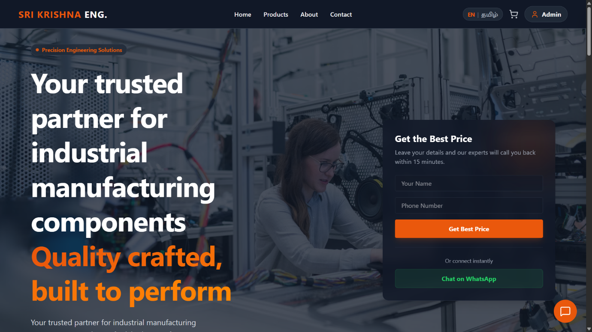

Home Page
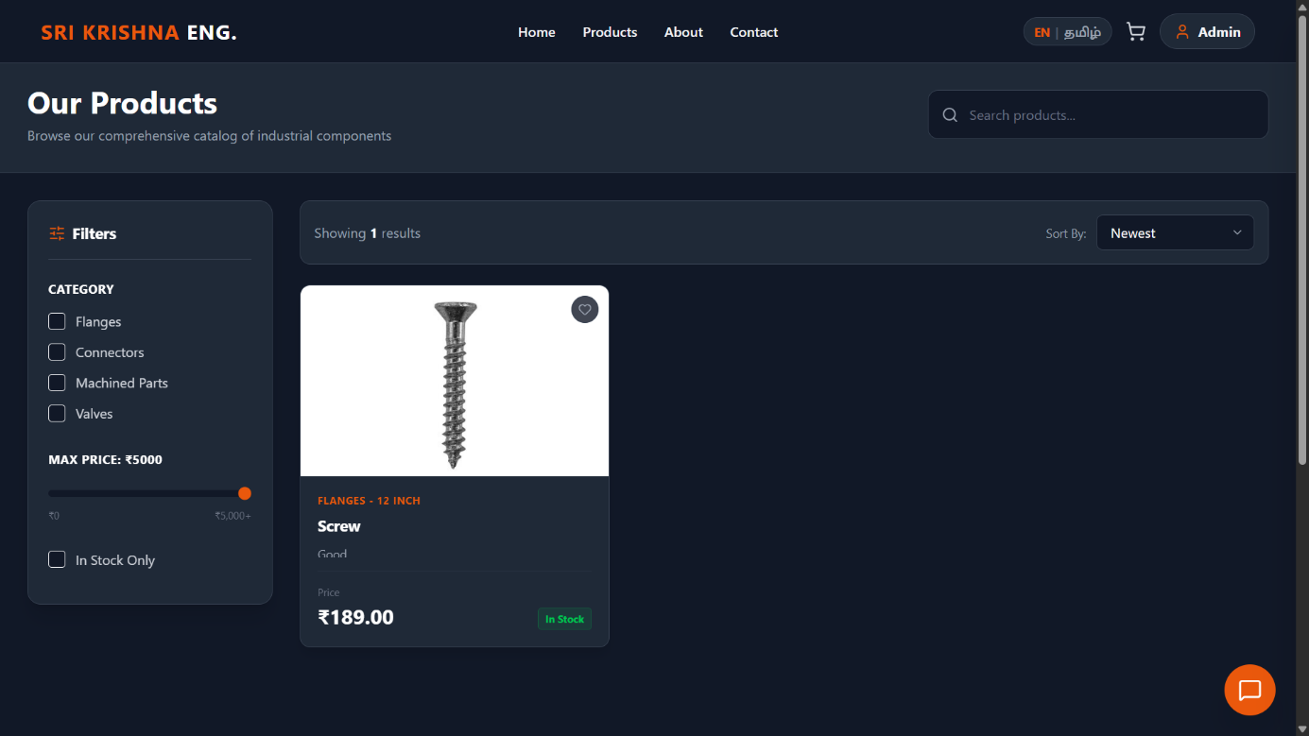

Product Page

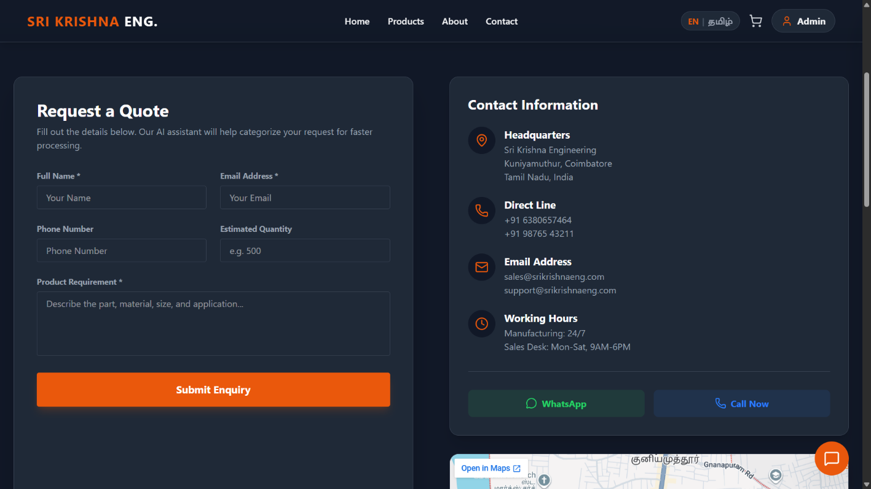

Contact Page

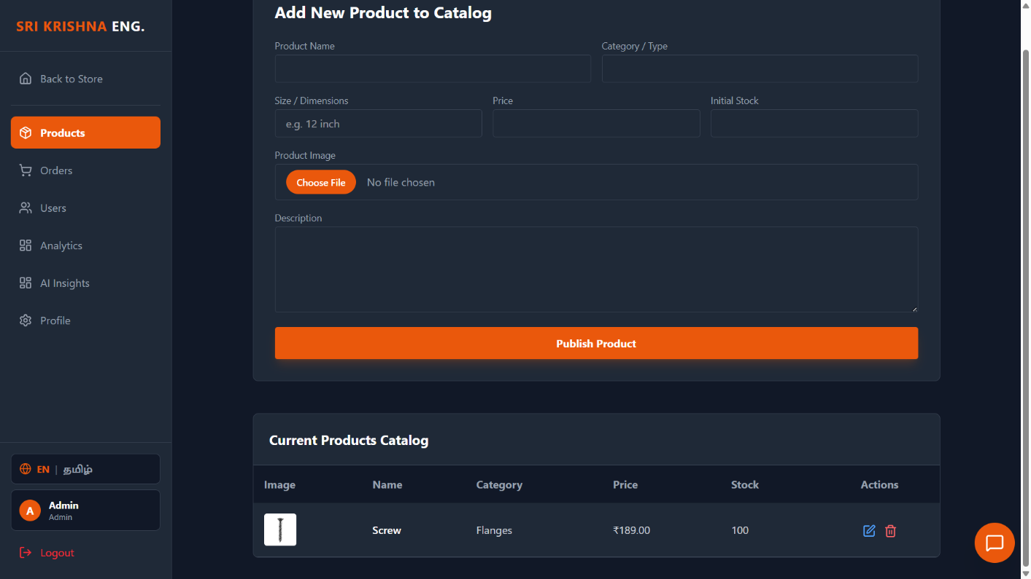

Admin Dashboard

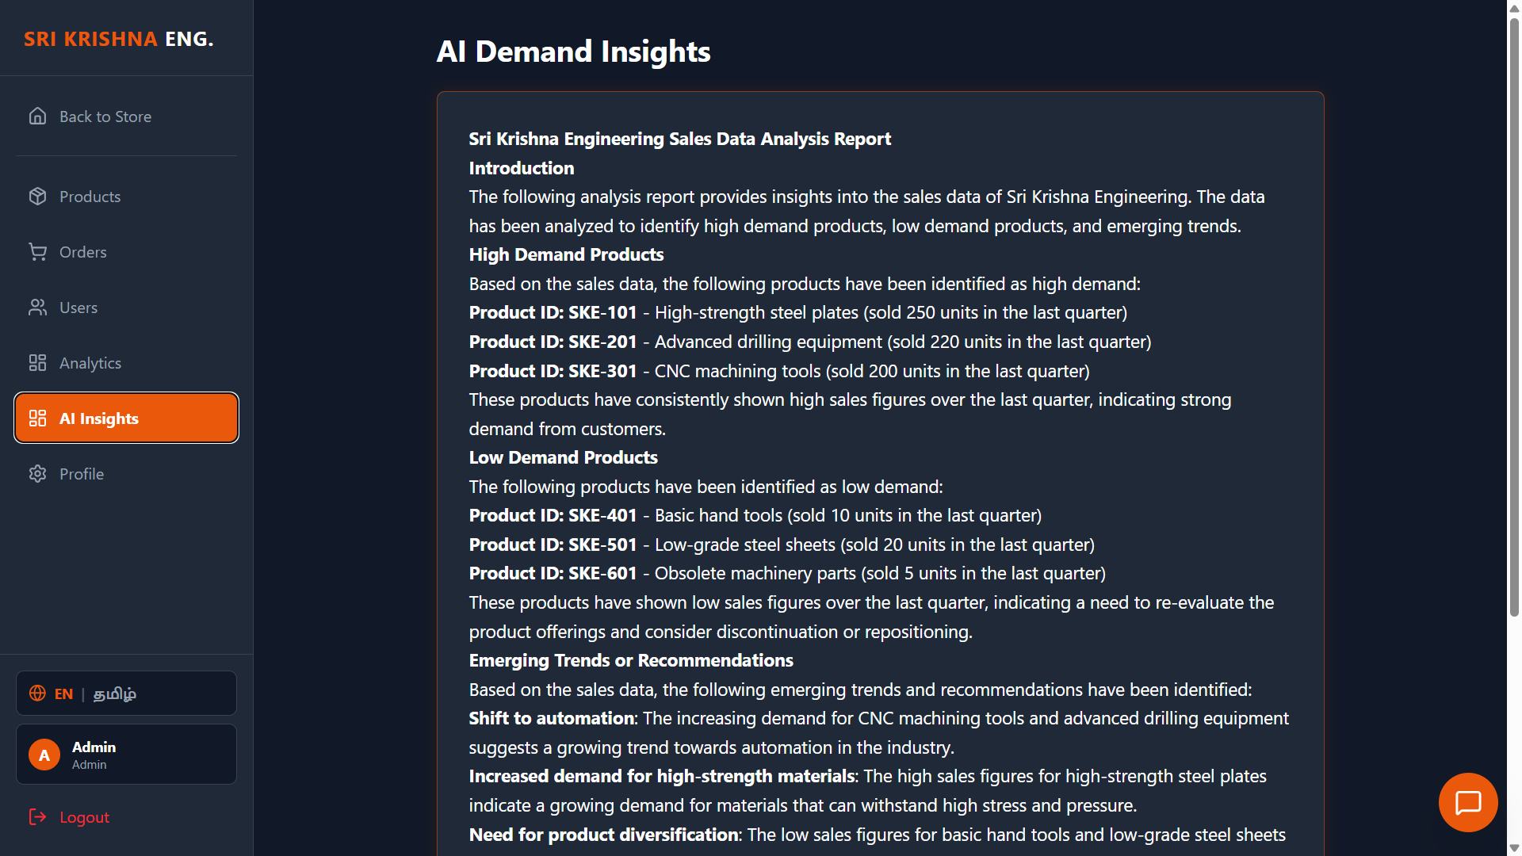

A.5 AI Insights

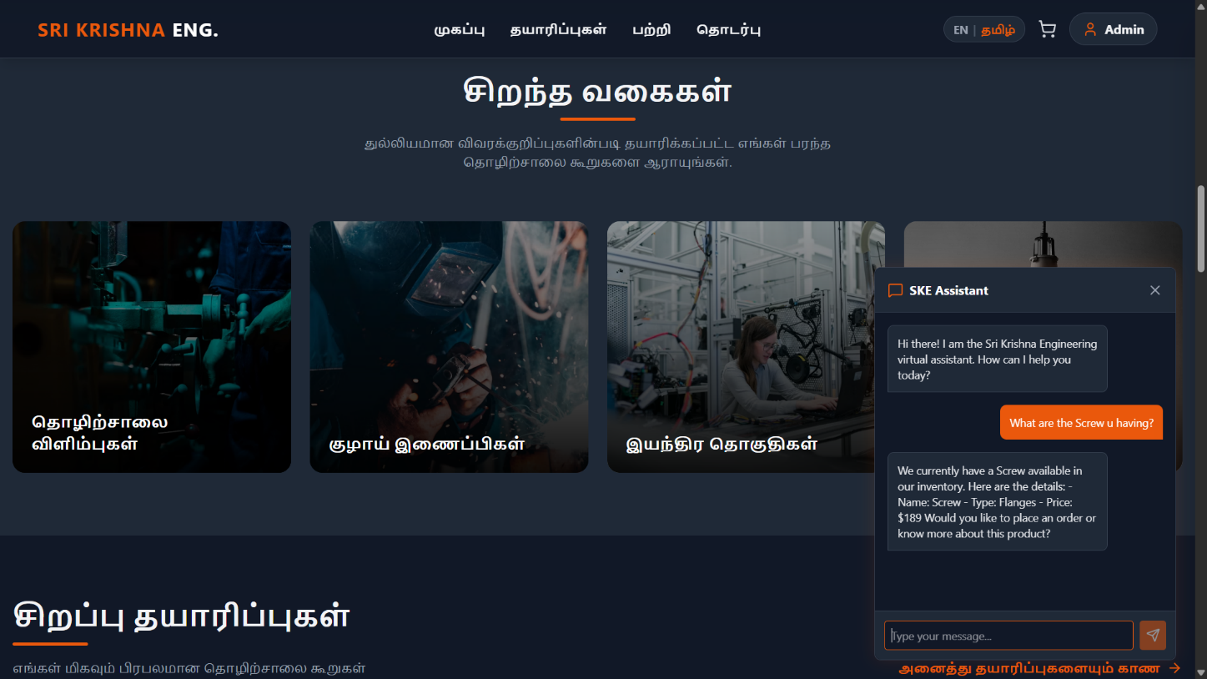

A.6 AI Chatbot

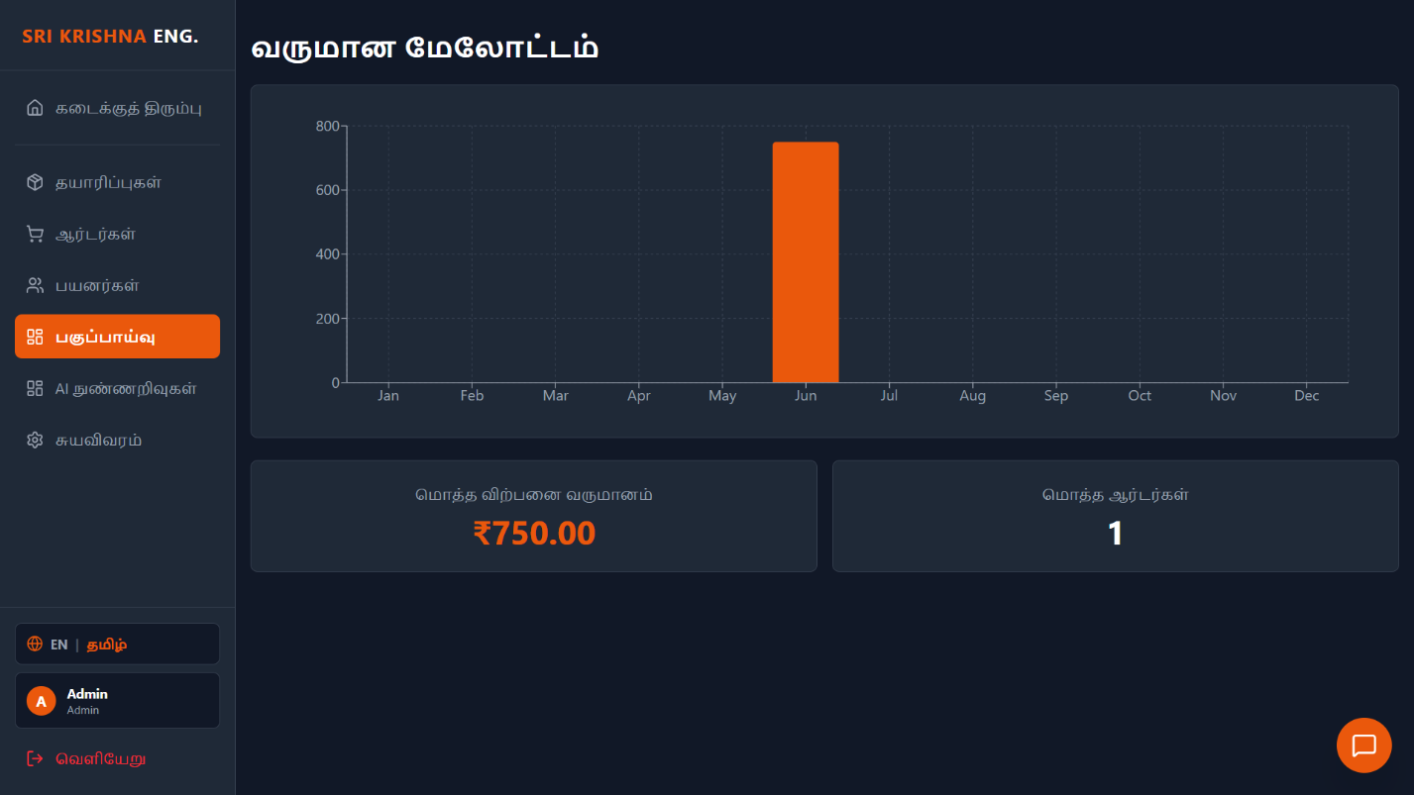

A.7 Multilinhual Support

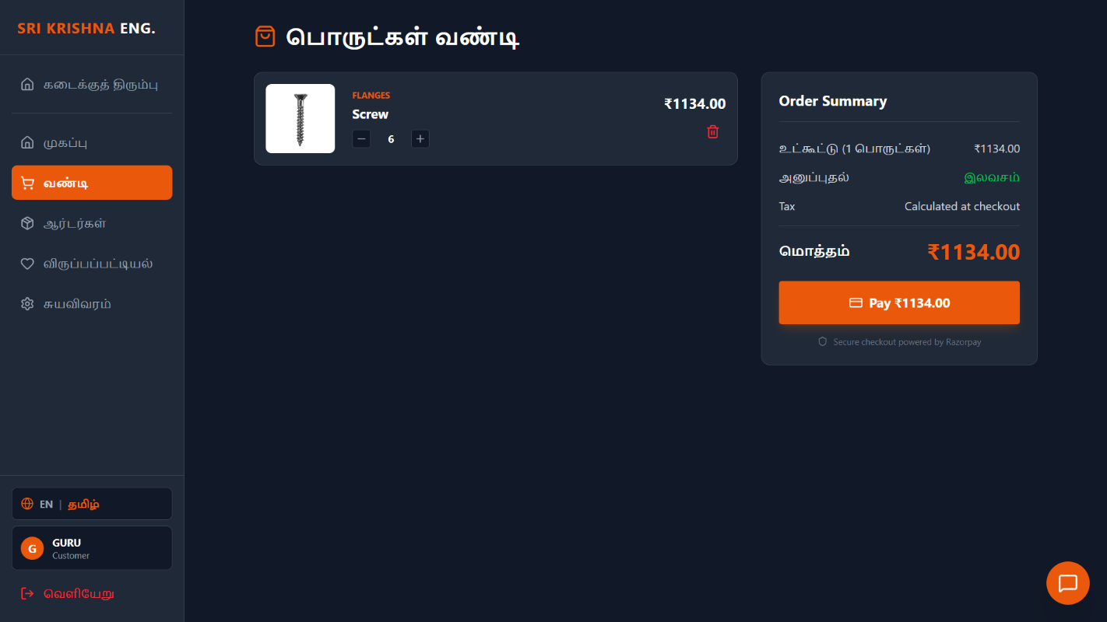

A.8 Real Time Purchase

SOURCE CODE

Home.jsx

import { useState, useEffect, useRef } from 'react';
import { Link, useNavigate } from 'react-router-dom';
import api from '../services/api';
import ProductCard from '../components/ProductCard';
import { motion, useInView } from 'framer-motion';
import { useLanguage } from '../context/LanguageContext';
import { Search, ShieldCheck, Truck, Clock, Award, ChevronRight, Settings, Users, Star, ArrowRight, CheckCircle2 } from 'lucide-react';
import toast from 'react-hot-toast';
import { getImageUrl } from '../services/imageUrl';

// Reusable animated counter component
function AnimatedCounter({ value, title }) {
const ref = useRef(null);
const isInView = useInView(ref, { once: true, margin: "-100px" });

return (
<div ref={ref} className="text-center p-6 bg-industrial-800 rounded-lg border border-industrial-700">
<h3 className="text-4xl md:text-5xl font-bold text-industrial-orange mb-2">
{isInView ? (
<motion.span
initial={{ opacity: 0, y: 20 }}
animate={{ opacity: 1, y: 0 }}
transition={{ duration: 0.5 }}
>
{value}
</motion.span>
) : "0"}
</h3>
<p className="text-gray-400 text-base font-medium">{title}</p>
</div>
);
}

export default function Home() {
const [featured, setFeatured] = useState([]);
const [searchQuery, setSearchQuery] = useState('');
const [searchResults, setSearchResults] = useState([]);
const [isSearching, setIsSearching] = useState(false);
const [showDropdown, setShowDropdown] = useState(false);
const { t } = useLanguage();

const [leadForm, setLeadForm] = useState({ name: '', phone: '' });
const searchRef = useRef(null);
const navigate = useNavigate();

useEffect(() => {
const fetchFeatured = async () => {
try {
const { data } = await api.get('/products');
setFeatured(data.slice(0, 4));
} catch (error) {
console.error(error);
}
};
fetchFeatured();
}, []);

// Handle click outside for search dropdown
useEffect(() => {
const handleClickOutside = (event) => {
if (searchRef.current && !searchRef.current.contains(event.target)) {
setShowDropdown(false);
}
};
document.addEventListener('mousedown', handleClickOutside);
return () => document.removeEventListener('mousedown', handleClickOutside);
}, []);

const handleSearch = async (e) => {
const query = e.target.value;
setSearchQuery(query);

if (query.length > 2) {
setIsSearching(true);
setShowDropdown(true);
try {
const { data } = await api.post('/ai/search', { query });
setSearchResults(data);
} catch (error) {
console.error("AI Search error:", error);
} finally {
setIsSearching(false);
}
} else {
setSearchResults([]);
setShowDropdown(false);
}
};

const handleLeadSubmit = (e) => {
e.preventDefault();
if (!leadForm.name || !leadForm.phone) {
toast.error("Please fill in all fields");
return;
}
toast.success("Thank you! Our team will contact you shortly with the best price.");
setLeadForm({ name: '', phone: '' });
};

// Animation variants
const fadeIn = {
hidden: { opacity: 0, y: 20 },
visible: { opacity: 1, y: 0, transition: { duration: 0.6 } }
};

const staggerContainer = {
hidden: { opacity: 0 },
visible: {
opacity: 1,
transition: { staggerChildren: 0.2 }
}
};

return (
<div className="flex flex-col min-h-screen overflow-hidden">

{/* 1. HERO SECTION */}
<section className="relative min-h-[80vh] md:min-h-[90vh] flex items-center pt-20 pb-12 md:pt-24 md:pb-16 lg:pt-10">
<div className="absolute inset-0 bg-[url('https://images.unsplash.com/photo-1581091226825-a6a2a5aee158?ixlib=rb-4.0.3&auto=format&fit=crop&w=1920&q=80')] bg-cover bg-center bg-fixed"></div>
<div className="absolute inset-0 bg-industrial-900/75"></div>

<div className="container mx-auto px-6 lg:px-12 xl:px-20 relative z-10 mt-12 md:mt-0">
<div className="grid lg:grid-cols-2 gap-8 lg:gap-16 items-center">
{/* Left Content */}
<motion.div
initial="hidden" animate="visible" variants={fadeIn}
className="max-w-2xl"
>
<div className="inline-flex items-center gap-2 px-3 py-1 rounded-full bg-industrial-800/80 border border-industrial-700 text-industrial-orange text-sm font-bold mb-6 backdrop-blur-sm">
<span className="w-2 h-2 rounded-full bg-industrial-orange animate-pulse"></span>
{t('hero.title')}
</div>
<h1 className="text-3xl sm:text-5xl md:text-6xl lg:text-7xl font-bold mb-4 md:mb-6 text-white tracking-tight leading-tight">
{t('hero.subtitle').split('.')[0]} <br />
<span className="text-transparent bg-clip-text bg-gradient-to-r from-industrial-orange to-orange-400">
{t('hero.subtitle').split('.')[1]}
</span>
</h1>
<p className="text-base sm:text-xl text-gray-300 mb-6 md:mb-8 max-w-lg leading-relaxed">
{t('hero.subtitle')}
</p>
<div className="flex flex-wrap gap-4">
<Link to="/products" className="btn-primary text-lg px-8 py-4 flex items-center gap-2 group">
{t('hero.cta')} <ArrowRight size={20} className="group-hover:translate-x-1 transition-transform" />
</Link>
<Link to="/contact" className="btn-secondary text-lg px-8 py-4 bg-industrial-800/50 backdrop-blur-sm">
{t('hero.ctaSecondary')}
</Link>
</div>
</motion.div>

{/* Right Content - Lead Form */}
<motion.div
initial={{ opacity: 0, x: 50 }} animate={{ opacity: 1, x: 0 }} transition={{ duration: 0.8, delay: 0.2 }}
className="hidden lg:block justify-self-end w-full max-w-md"
>
<div className="glass-panel rounded-2xl p-8 relative overflow-hidden">
<div className="absolute top-0 right-0 w-32 h-32 bg-industrial-orange/20 blur-[50px]"></div>
<h3 className="text-2xl font-bold text-white mb-2 relative z-10">{t('home.getBestPrice')}</h3>
<p className="text-gray-400 mb-6 relative z-10">{t('home.getBestPriceDesc')}</p>

<form onSubmit={handleLeadSubmit} className="space-y-4 relative z-10">
<div>
<input
type="text" placeholder={t('home.yourName')}
className="input-field bg-industrial-900/50 border-industrial-700/50"
value={leadForm.name} onChange={e => setLeadForm({ ...leadForm, name: e.target.value })}
/>
</div>
<div>
<input
type="tel" placeholder={t('home.phoneNumber')}
className="input-field bg-industrial-900/50 border-industrial-700/50"
value={leadForm.phone} onChange={e => setLeadForm({ ...leadForm, phone: e.target.value })}
/>
</div>
<button type="submit" className="w-full btn-primary py-3">{t('home.getBestPriceBtn')}</button>
</form>

<div className="mt-6 pt-6 border-t border-industrial-700/50 text-center relative z-10">
<p className="text-sm text-gray-400 mb-3">{t('home.orConnect')}</p>
<a href={`https://wa.me/${import.meta.env.VITE_WHATSAPP_NUMBER || '6369174670'}`} target="_blank" rel="noopener noreferrer" className="flex items-center justify-center gap-2 w-full py-3 rounded-lg bg-[#25D366]/10 text-[#25D366] hover:bg-[#25D366]/20 border border-[#25D366]/20 transition-colors font-bold">
{t('home.chatWhatsApp')}
</a>
</div>
</div>
</motion.div>
</div>
</div>
</section>

{/* 2. TRUST BAR */}
<section className="bg-industrial-800 border-y border-industrial-700 relative z-20 shadow-xl">
<div className="container mx-auto px-4 py-6">
<div className="flex flex-wrap justify-center md:justify-between items-center gap-4 md:gap-6">
{[
{ icon: <ShieldCheck className="text-industrial-orange" />, text: t('home.verifiedQuality') },
{ icon: <Truck className="text-industrial-orange" />, text: t('home.fastGlobalDelivery') },
{ icon: <Settings className="text-industrial-orange" />, text: t('home.customManufacturing') },
{ icon: <Award className="text-industrial-orange" />, text: t('home.lowestPricing') },
{ icon: <Clock className="text-industrial-orange" />, text: t('home.aiSupport') }
].map((item, i) => (
<div key={i} className="flex items-center gap-3 font-semibold text-gray-300">
{item.icon}
<span>{item.text}</span>
</div>
))}
</div>
</div>
</section>

{/* 3. AI SMART SEARCH */}
<section className="py-16 bg-industrial-900 relative">
<div className="container mx-auto px-4 max-w-4xl relative z-30" ref={searchRef}>
<div className="text-center mb-8">
<h2 className="text-3xl font-bold mb-4">{t('home.findExactly')}</h2>
<p className="text-gray-400">{t('home.findExactlyDesc')}</p>
</div>

<div className="relative">
<div className="absolute inset-y-0 left-0 pl-4 flex items-center pointer-events-none">
<Search className="h-6 w-6 text-gray-500" />
</div>
<input
type="text"
className="block w-full pl-12 pr-4 py-5 bg-industrial-800 border-2 border-industrial-700 rounded-xl text-lg text-white placeholder-gray-500 focus:outline-none focus:border-industrial-orange shadow-lg transition-colors"
placeholder={t('hero.search')}
value={searchQuery}
onChange={handleSearch}
onFocus={() => { if (searchQuery.length > 2) setShowDropdown(true); }}
/>
{isSearching && (
<div className="absolute inset-y-0 right-0 pr-4 flex items-center">
<div className="animate-spin rounded-full h-6 w-6 border-b-2 border-industrial-orange"></div>
</div>
)}

{/* Dropdown Results */}
{showDropdown && (
<motion.div
initial={{ opacity: 0, y: 10 }} animate={{ opacity: 1, y: 0 }}
className="absolute mt-2 w-full bg-industrial-800 border border-industrial-700 rounded-xl shadow-2xl overflow-hidden z-50 max-h-96 overflow-y-auto"
>
{searchResults.length > 0 ? (
<div className="p-2">
<p className="px-3 py-2 text-xs font-bold text-industrial-orange uppercase tracking-wider">{t('home.aiMatches')}</p>
{searchResults.map((product) => (
<div key={product._id} className="flex items-center gap-4 p-3 hover:bg-industrial-700 rounded-lg cursor-pointer transition-colors" onClick={() => navigate(`/products`)}>
<div className="w-12 h-12 bg-industrial-900 rounded overflow-hidden flex-shrink-0">
{product.imageUrl ? <img src={getImageUrl(product.imageUrl)} alt={product.name} className="w-full h-full object-cover" /> : <div className="w-full h-full flex items-center justify-center text-xs text-gray-600">No img</div>}
</div>
<div className="flex-1">
<h4 className="font-bold text-white text-sm">{product.name}</h4>
<p className="text-xs text-gray-400">{product.type} • {product.size}</p>
</div>
<div className="font-bold text-industrial-orange">₹{product.price?.toFixed(2)}</div>
</div>
))}
</div>
) : !isSearching && searchQuery.length > 2 ? (
<div className="p-8 text-center text-gray-400">
<p>{t('home.noMatches')} <Link to="/contact" className="text-industrial-orange hover:underline">{t('home.contactForCustom')}</Link> {t('home.forCustomMfg')}</p>
</div>
) : null}
</motion.div>
)}
</div>
</div>
</section>

{/* 4. TOP CATEGORIES */}
<section className="py-20 bg-industrial-800">
<div className="container mx-auto px-4">
<div className="text-center mb-16">
<h2 className="text-4xl font-bold mb-4">{t('home.topCategories')}</h2>
<div className="w-24 h-1 bg-industrial-orange mx-auto rounded-full mb-4"></div>
<p className="text-gray-400 max-w-2xl mx-auto">{t('home.topCategoriesDesc')}</p>
</div>

<div className="grid grid-cols-1 sm:grid-cols-2 lg:grid-cols-4 gap-6">
{[
{ title: t('home.industrialFlanges'), img: "https://images.unsplash.com/photo-1581092335397-9583eb92d232?auto=format&fit=crop&w=800&q=80" },
{ title: t('home.pipeConnectors'), img: "https://images.unsplash.com/photo-1504328345606-18bbc8c9d7d1?auto=format&fit=crop&w=800&q=80" },
{ title: t('home.machinedBlocks'), img: "https://images.unsplash.com/photo-1581091226825-a6a2a5aee158?auto=format&fit=crop&w=800&q=80" },
{ title: t('home.customParts'), img: "https://images.unsplash.com/photo-1565814329452-e1efa11c5b89?auto=format&fit=crop&w=800&q=80" }
].map((cat, i) => (
<motion.div
key={i}
initial={{ opacity: 0, y: 30 }}
whileInView={{ opacity: 1, y: 0 }}
viewport={{ once: true }}
transition={{ delay: i * 0.1 }}
className="group relative h-80 rounded-2xl overflow-hidden cursor-pointer"
onClick={() => navigate('/products')}
>
<div className="absolute inset-0 bg-black/40 group-hover:bg-black/20 transition-colors duration-500 z-10"></div>
<div className="absolute inset-0 bg-gradient-to-t from-black/90 via-black/40 to-transparent z-10"></div>
<img src={cat.img} alt={cat.title} className="w-full h-full object-cover group-hover:scale-110 transition-transform duration-700" />
<div className="absolute bottom-0 left-0 w-full p-6 z-20 flex justify-between items-end">
<h3 className="text-xl font-bold text-white group-hover:text-industrial-orange transition-colors">{cat.title}</h3>
<div className="w-10 h-10 rounded-full bg-industrial-orange/90 flex items-center justify-center opacity-0 group-hover:opacity-100 translate-x-4 group-hover:translate-x-0 transition-all duration-300">
<ChevronRight className="text-white" />
</div>
</div>
</motion.div>
))}
</div>
</div>
</section>

{/* 5. FEATURED PRODUCTS */}
<section className="py-20 bg-industrial-900">
<div className="container mx-auto px-4">
<div className="flex flex-col md:flex-row justify-between items-end mb-12">
<div className="mb-4 md:mb-0">
<h2 className="text-4xl font-bold mb-4">{t('home.featured')}</h2>
<div className="w-24 h-1 bg-industrial-orange rounded-full mb-4"></div>
<p className="text-gray-400">{t('home.featuredSub')}</p>
</div>
<Link to="/products" className="group flex items-center text-industrial-orange font-bold hover:text-orange-400 transition-colors">
{t('home.viewAll')} <ArrowRight size={20} className="ml-2 group-hover:translate-x-2 transition-transform" />
</Link>
</div>

<div className="grid grid-cols-1 sm:grid-cols-2 lg:grid-cols-4 gap-8">
{featured.map((product, i) => (
<motion.div
key={product._id}
initial={{ opacity: 0, scale: 0.95 }}
whileInView={{ opacity: 1, scale: 1 }}
viewport={{ once: true }}
transition={{ delay: i * 0.1 }}
>
<ProductCard product={product} />
</motion.div>
))}
{featured.length === 0 && (
<div className="col-span-full p-12 text-center text-gray-500 bg-industrial-800 rounded-xl border border-industrial-700">
{t('home.loadingProducts')}
</div>
)}
</div>
</div>
</section>

{/* 6. WHY CHOOSE US */}
<section className="py-20 bg-industrial-800">
<div className="container mx-auto px-4">
<div className="grid lg:grid-cols-2 gap-16 items-center">
<motion.div
initial={{ opacity: 0, x: -50 }} whileInView={{ opacity: 1, x: 0 }} viewport={{ once: true }}
>
<h2 className="text-4xl font-bold mb-6">{t('home.whyIndustry')} <span className="text-industrial-orange">{t('home.chooseUs')}</span></h2>
<p className="text-gray-400 text-lg mb-8 leading-relaxed">
{t('home.whyIndustryDesc')}
</p>

<div className="space-y-6">
{[
{ icon: <Settings size={28} />, title: t('home.precisionEng'), desc: t('home.precisionEngDesc') },
{ icon: <ShieldCheck size={28} />, title: t('home.durableMaterials'), desc: t('home.durableMaterialsDesc') },
{ icon: <Users size={28} />, title: t('home.experiencedTeam'), desc: t('home.experiencedTeamDesc') }
].map((item, i) => (
<div key={i} className="flex items-start gap-4 p-4 rounded-xl hover:bg-industrial-700/50 border border-transparent hover:border-industrial-700 transition-colors">
<div className="w-14 h-14 rounded-lg bg-industrial-900 border border-industrial-700 flex items-center justify-center text-industrial-orange flex-shrink-0 shadow-lg">
{item.icon}
</div>
<div>
<h4 className="text-xl font-bold text-white mb-1">{item.title}</h4>
<p className="text-gray-400">{item.desc}</p>
</div>
</div>
))}
</div>
</motion.div>

<motion.div
initial={{ opacity: 0, scale: 0.9 }} whileInView={{ opacity: 1, scale: 1 }} viewport={{ once: true }}
className="relative h-[350px] sm:h-[450px] lg:h-[600px] rounded-2xl overflow-hidden shadow-2xl border border-industrial-700"
>
<img src="https://images.unsplash.com/photo-1504328345606-18bbc8c9d7d1?ixlib=rb-4.0.3&auto=format&fit=crop&w=800&q=80" alt="Factory" className="w-full h-full object-cover" />
<div className="absolute inset-0 bg-industrial-900/40 mix-blend-multiply"></div>

{/* Floating badge */}
<div className="absolute bottom-4 left-4 md:bottom-8 md:left-8 glass-panel p-4 md:p-6 rounded-xl flex items-center gap-3 md:gap-4 animate-bounce-slow">
<div className="w-16 h-16 rounded-full bg-industrial-orange flex items-center justify-center">
<Award size={32} className="text-white" />
</div>
<div>
<div className="text-sm text-gray-400 font-bold uppercase tracking-wider">{t('home.certified')}</div>
<div className="text-xl font-bold text-white">ISO 9001:2015</div>
</div>
</div>
</motion.div>
</div>
</div>
</section>

{/* 7. STATS / ACHIEVEMENTS */}
<section className="py-20 bg-industrial-900 border-y border-industrial-700 relative overflow-hidden">
{/* Subtle background pattern */}
<div className="absolute inset-0 opacity-5" style={{ backgroundImage: 'radial-gradient(#EA580C 1px, transparent 1px)', backgroundSize: '40px 40px' }}></div>

<div className="container mx-auto px-4 relative z-10">
<div className="grid grid-cols-2 md:grid-cols-4 gap-6">
<AnimatedCounter value="10+" title={t('home.yearsExperience')} />
<AnimatedCounter value="500+" title={t('home.globalClients')} />
<AnimatedCounter value="1,000+" title={t('home.productsMfg')} />
<AnimatedCounter value="24/7" title={t('home.dedicatedSupport')} />
</div>
</div>
</section>

{/* 8. TESTIMONIALS */}
<section className="py-20 bg-industrial-800">
<div className="container mx-auto px-4">
<div className="text-center mb-16">
<h2 className="text-4xl font-bold mb-4">{t('home.clientsSay')}</h2>
<div className="w-24 h-1 bg-industrial-orange mx-auto rounded-full mb-4"></div>
</div>

<div className="grid md:grid-cols-3 gap-8">
{[
{ name: "Rahul S.", company: "TechBuild Infra", quote: t('home.testimonial1') },
{ name: "Michael T.", company: "HeavyMach Corp", quote: t('home.testimonial2') },
{ name: "Priya M.", company: "Global Piping Solutions", quote: t('home.testimonial3') }
].map((review, i) => (
<motion.div
key={i}
initial={{ opacity: 0, y: 20 }}
whileInView={{ opacity: 1, y: 0 }}
viewport={{ once: true }}
transition={{ delay: i * 0.1 }}
className="bg-industrial-900 p-8 rounded-2xl border border-industrial-700 relative"
>
<div className="flex gap-1 text-industrial-orange mb-6">
{[...Array(5)].map((_, i) => <Star key={i} size={18} fill="currentColor" />)}
</div>
<p className="text-gray-300 italic mb-8 leading-relaxed">"{review.quote}"</p>
<div className="flex items-center gap-4">
<div className="w-12 h-12 bg-industrial-800 rounded-full flex items-center justify-center font-bold border border-industrial-700 text-industrial-orange">
{review.name.charAt(0)}
</div>
<div>
<h4 className="font-bold text-white">{review.name}</h4>
<p className="text-xs text-gray-500 uppercase tracking-wider">{review.company}</p>
</div>
</div>
{/* Quote watermark */}
<div className="absolute top-4 right-6 text-6xl text-industrial-800 font-serif opacity-50">"</div>
</motion.div>
))}
</div>
</div>
</section>

{/* 9. BLOG / INSIGHTS PREVIEW */}
<section className="py-20 bg-industrial-900">
<div className="container mx-auto px-4">
<div className="flex flex-col sm:flex-row justify-between items-start sm:items-end gap-4 mb-12">
<div>
<h2 className="text-4xl font-bold mb-4">{t('home.industryInsights')}</h2>
<div className="w-24 h-1 bg-industrial-orange rounded-full mb-4"></div>
</div>
</div>

<div className="grid md:grid-cols-2 gap-8">
<div className="group cursor-pointer bg-industrial-800 rounded-xl overflow-hidden border border-industrial-700 hover:border-industrial-orange/50 transition-colors">
<div className="h-64 overflow-hidden relative">
<img src="https://images.unsplash.com/photo-1581091226825-a6a2a5aee158?auto=format&fit=crop&w=800&q=80" alt="Steel" className="w-full h-full object-cover group-hover:scale-105 transition-transform duration-500" />
<div className="absolute top-4 left-4 bg-industrial-orange text-white text-xs font-bold px-3 py-1 rounded uppercase">{t('home.marketTrends')}</div>
</div>
<div className="p-8">
<h3 className="text-2xl font-bold mb-3 text-white group-hover:text-industrial-orange transition-colors">{t('home.blogTitle1')}</h3>
<p className="text-gray-400 mb-6 line-clamp-2">{t('home.blogDesc1')}</p>
<div className="text-sm text-gray-500 font-medium">May 24, 2026 • 5 min read</div>
</div>
</div>

<div className="group cursor-pointer bg-industrial-800 rounded-xl overflow-hidden border border-industrial-700 hover:border-industrial-orange/50 transition-colors">
<div className="h-64 overflow-hidden relative">
<img src="https://images.unsplash.com/photo-1581092160607-ee22621dd758?auto=format&fit=crop&w=800&q=80" alt="Flanges" className="w-full h-full object-cover group-hover:scale-105 transition-transform duration-500" />
<div className="absolute top-4 left-4 bg-industrial-orange text-white text-xs font-bold px-3 py-1 rounded uppercase">{t('home.technicalGuide')}</div>
</div>
<div className="p-8">
<h3 className="text-2xl font-bold mb-3 text-white group-hover:text-industrial-orange transition-colors">{t('home.blogTitle2')}</h3>
<p className="text-gray-400 mb-6 line-clamp-2">{t('home.blogDesc2')}</p>
<div className="text-sm text-gray-500 font-medium">May 18, 2026 • 8 min read</div>
</div>
</div>
</div>
</div>
</section>

{/* 10. CTA SECTION */}
<section className="py-24 relative overflow-hidden">
<div className="absolute inset-0 bg-industrial-orange"></div>
<div className="absolute inset-0 bg-[url('https://images.unsplash.com/photo-1581092334651-ddf7d0a293dc?ixlib=rb-4.0.3&auto=format&fit=crop&w=1920&q=80')] mix-blend-multiply opacity-20 bg-cover bg-center"></div>
<div className="container mx-auto px-4 relative z-10 text-center">
<h2 className="text-4xl md:text-5xl font-bold text-white mb-6">{t('home.lookingCustomMfg')}</h2>
<p className="text-xl text-white/90 mb-10 max-w-2xl mx-auto">
{t('home.lookingCustomMfgDesc')}
</p>
<div className="flex flex-col sm:flex-row gap-4 justify-center">
<Link to="/contact" className="bg-industrial-900 text-white hover:bg-industrial-800 text-lg font-bold py-4 px-10 rounded shadow-2xl transition-all hover:-translate-y-1">
{t('home.requestQuote')}
</Link>
<a href={`https://wa.me/${import.meta.env.VITE_WHATSAPP_NUMBER || '6369174670'}`} target="_blank" rel="noopener noreferrer" className="bg-white text-industrial-900 hover:bg-gray-100 text-lg font-bold py-4 px-10 rounded shadow-2xl transition-all hover:-translate-y-1 flex items-center justify-center gap-2">
{t('home.whatsAppUs')}
</a>
</div>
</div>
</section>

</div>
);
}

C.TIMESHEET

